

**Lab No 8 Artificial Intelligence**

Name Tahir Hussain

ID BIT-23F-009

Class Artificial Intelligence

Data 8/12/24

Class Teacher Miss Aqsa Umar

**Task1.**

Write a Python class named Car that represents a car. The class should have the following attributes:

* make: the car's make (e.g., "Toyota")
* model: the car's model (e.g., "Corolla")
* year: the car's manufacturing year (e.g., 2020)
* mileage: the number of miles driven by the car.

The class should have the following methods:

* __init__(self): Constructor to initialize the car's attributes.
* display_info(): Displays the car's information (make, model, year, mileage).
* drive(miles): Increases the mileage by the specified number of miles

Code:

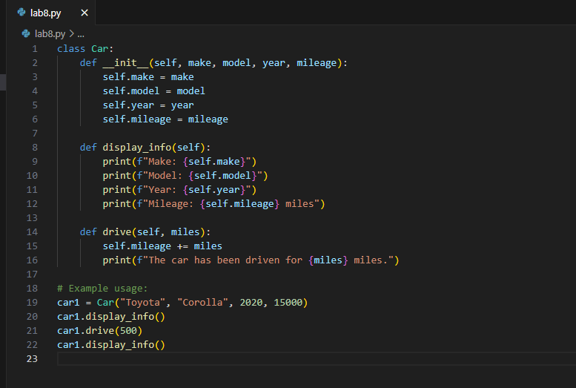

**Output:**

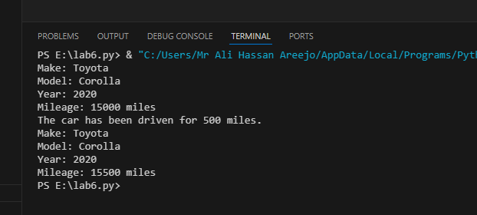

**Task 2.**

Write a Python class named Student that represents a student. The class should have the following attributes:

* name: the student's name.
* age: the student's age.
* marks: a list of the student's marks.

The class should have the following methods:

* __init__(self): Constructor to initialize the student's attributes.
* add_marks(self, marks): Adds a list of marks to the student's marks list.
* average_marks(self): Calculates and returns the average of the student's marks.
* display_info(self): Displays the student's information (name, age, average marks).

**Code:**

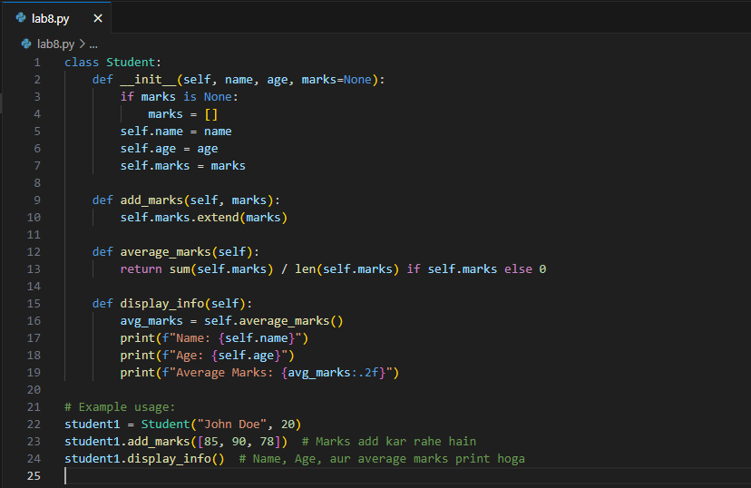

**Output:**

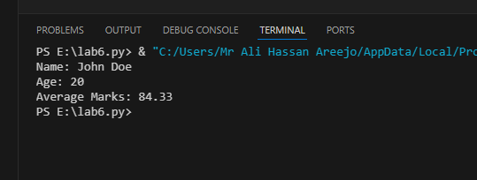

**Task 3.**

Write a Python class named BankAccount that represents a bank account. The class should have the following attributes:

* account_holder: the name of the account holder.
* balance: the balance of the account.

The class should have the following methods:

* __init__(self): Constructor to initialize the account holder's name and balance.
* deposit(self, amount): Deposits an amount into the account.
* withdraw(self, amount): Withdraws an amount from the account if there are sufficient funds.
* display_balance(self): Displays the current balance of the account.

**Code:**

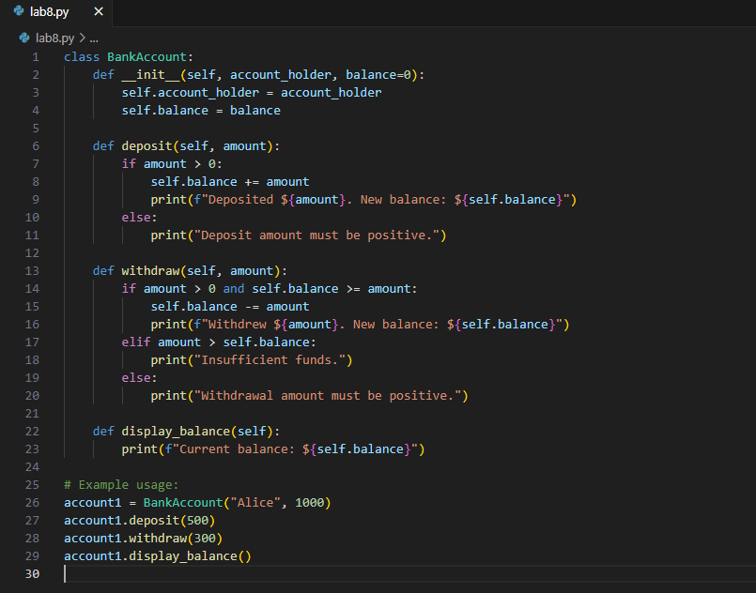

**Output:**

